Friends of the Westfield Memorial Library Newsletter

Spring 2025 Edition

**ALL the News**

**That Fits**

**We Print**

**ALL the News**

**That Fits**

**We Print**

Co-Presidents: Cindy Colicchio and Christine Mason

## Prepared by Michael Miller and Jerry Skotnicki

www.fwmlnj.org

**Welcome**

Happy Spring! Just as flowers are beginning to bloom, our spring programs are blossoming. We are very excited about the robust schedule of events for 2025. Following very successfulPop-up Jewelry and Jigsaw Puzzle sales, as well as an exceptional month long Black History Month Celebration, brace yourself for the breadth and depth of our spring programming (see below). Once again, our sincere appreciation goes out to our wonderful volunteers who make our programs prosper.Participation in our activities is a very rewarding experience. If you would like to volunteer to help with any of these programs, please send an email to info@fwmlnj.org. All volunteers are greatly appreciated

Cindy Colicchio and Christine Mason, Co-Presidents

**Upcoming Events**

March 1: Friends Program for Children

Winnie the Pooh from Bright Star Theater

March 8: Friends Program for Children

Anthony Salazar, Magician

March 10: Friends of the WML Board Meeting

March 11: Friends Sharing the Warmth Knitting Club

March 15: Friends Program for Children

The Eyes of the Wild

March 19: Hale Speaker Series: Gavin Shulman "Which Leads Me to Today:

How Westfield Inspired My Career in TV”

March 19: Book Discussion Group - “West with Giraffes ”by Lynda Rutledge (see article within)

March 25: Friends Sharing the Warmth Knitting Club

March 26: Met Opera Program: AIDA (VERDI), NEW PRODUCTION

April 2: Hale Speaker Series: Kathryn VanArendonk

"Why Do We Need TV Critics in the Age of the Algorithm?”

April 8: Friends Sharing the Warmth Knitting Club

April 9: Met Opera Program: DIE ZAUBERFLOETE (MOZART)

April 14: Friends of the WML Board Meeting

April 22: Friends Sharing the Warmth Knitting Club

**2025 Spring Book Sale (see within)**

Donation Days:

Wednesday through Saturday

April 23 – 26

Sale Days:

Wednesday through Sunday

April 30 – May 4

May 6: Friends Sharing the Warmth Knitting Club

May 12: Friends of the WML Board Meeting

May 20: Friends Sharing the Warmth Knitting Club

**HALE SPEAKER SERIES**

Since its inception, the Hale Speaker Series has continued to gain in popularity with local residents who enjoy hearing from individuals with ties to Westfield.

Thus, the 16th annual series, that begins soon at Westfield Memorial Library, will offer talks by four interesting speakers who are Westfield High graduates or Westfield residents.

**Gavin Shulman**, the senior TV producer for Today with Jenna and Friends on NBC, will kick off this year’s offerings on March 19, with a talk on “Which Leads Me to Today: How Westfield Inspired My Career in TV.” Shulman, a 2001 alumnus of WHS, will detail his path from work on the school’s newspaper to his current post.

Westfield resident **Kathryn VanArendonk** is a TV and comedy critic for Vulture and New York magazine. Her talk, set for April 2, is titled “Why Do We Need TV Critics in the Age of the Algorithim?” VanArendonk, who holds a PhD from Stanford University, is president of the Westfield Memorial Library Foundation.

**Westfield Police Chief Christopher Battiloro**, a 1991 graduate of Westfield High, will speak Oct. 15 on “The Westfield Police Department: Crime and Public Safety in Our Town.” Battiloro, a Clemson University graduate, joined the Westfield Police Department in 1997.

**Stefanie Lalor,** who has owned an art/framing business for a quarter of a century, will discuss “The Artist Framer” in a talk scheduled for Nov. 19. Lalor, an award-winning artist, is a 1988 alumna of Westfield High and was awarded her MFA in Figurative Painting from the New York Academy of Art.

The Wednesday evening hour-long talks begin at 7 p.m. in the library’s meeting room. They are open to the public but pre-registration is required online at [www.wmlnj.org](http://www.wmlnj.org) or by calling 908-789-4090 ext. 0. The programs also are available on the library’s You Tube channel.

The Hale Speaker Series was founded by the late Lee Hale in memory of his wife, Anne, After Lee’s passing, the series was dedicated to both of them. Their daughter, Barbara Hale, is a member of the Speaker Series committee and introduces the speakers.

The Friends of Westfield Memorial Library hosts the Hale Series that is funded by the Lee and Anne Hale Fund and The Glasser Foundation.

Linnea Rhodes serves as chairman of the Hale Speaker Series committee that also includes Sherry Cronin, Marcy Lechner, Mary Orlando, Ellen Albertson and Tina Lesher.

**Friends of the Westfield Memorial Library**

**The Metropolitan Opera, NY City**

**2025-26 Operas - Wed 5 Series**

The Met has announced the program for the 2025-26 season and we will have 6 performances in our Met Wed-5 opera series with an excellent mix of classical operas, a new composition and a musical. There are no Met performances in January and February for us. After our very successful trip to NY City Ballet I will plan another one for February 2026.

More information will be forthcoming as soon as I get our subscription renewal forms and bus quotes. To retain our excellent seating we will most likely have to renew by beginning of April. So respond fast!

Oct 15 **7:30 PM** Don Giovanni (Mozart) **Bus 5:00**

Nov 5 **7:30PM** Carmen (Bizet) **Bus 5:00**

Dec 17 **7:30 PM**Porgy and Bess (Gershwin) **Bus. 5:00**

**Feb NYCITY BALLET AT LINCOLN CENTER** to be determined **Bus 5:00 PM**

Mar 11 **7:00 PM** Madama Butterfly (Puccini) **Bus 4:30**

Apr 22**7:00PM** Innocence (Saariaho) **Bus 4:30**

May 20 **7:00 PM** La Traviata (Verdi) **Bus 4:30**

**FOR INFORMATION CONTACT:**

**ULF DOLLING at 908-347-3563 or uhdoll@aol.com**

**Or FWML** [**www.fwmlnj.org**](http://www.fwmlnj.org)

**Bus will leave from the Westfield Memorial Library**

**The Friends Pop-Up Donated Jewelry Sale was a Gem!**

On Saturday, December 14, 2024 the Friends hosted a Pop-up Jewelry Sale in the Meeting Room of Westfield Memorial Library. The sale was crowned a success as we raised over $2,900, with keen interest by patrons and volunteers alike, The six hour event provided opportunities to look for unusual gifts and the timing was perfect for holiday shopping. We have collected donated pieces of jewelry, from costume to fine pieces. Each piece was sorted, individually priced and tagged. There was a separate section of the sale demarcated for special items. Thanks to all who have provided the donations which will help make our sale a success. Finally, thanks to all the many patrons who visited the sale and supported us. Importantly, we acknowledge and thank the Friends of the Summit Free Library who worked with us and were also generous to lend us jewelry cases, baskets etc. All proceeds go to funding Friends sponsored programs at the Westfield Memorial Library. At the entrance to the sale, there was a raffle available to patrons: the prize was a one day pass to the Metropolitan Museum of Art.



***3rd Annual Jigsaw Puzzle Sale a Huge Success***

The interlocking fit between puzzles and buyers made the third Annual Jigsaw Puzzle Sale, sponsored by the Friends, a huge success. The sale took place on January 22nd and 23rd, 2025 in the Meeting Room at the Westfield Memorial Library. More than 25 volunteers participated during three donation and two sale days. There were greater than 120 individual transactions to yield $2,119. Over 850 puzzles for all ages were donated during three days. These puzzles varied in size (25 to 4,000 pieces), format, complexity, and subject matter, including a separate children’s section. Thanks to all who have provided the donations, our hard working volunteers, and to all the many patrons who supported us and visited the sale . All proceeds go to funding Friends sponsored programs at the Westfield Memorial Library. Excess puzzles will be donated to local charities, including Inroads to Opportunities and Mitzvah Circle, and those remaining are being sold at the ongoing Friends’ Pop-Up Jigsaw Puzzle Sale in the library near the circulation desk. At the cashiers desk there were two raffles available to patrons: one prize was a jigsaw puzzle of their choice and the other prize was a one day pass to the Metropolitan Museum of Art



**Book Discussion Group: March 19th 2:00**

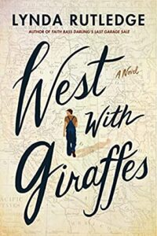***“West with Giraffes”* by Lynda Rutledge is the story of 17-year-old**

**Woodrow Wilson Nickel, who drives two giraffes across the U.S. in 1938. Along the way, he learns about himself through the challenges and adventures of the journey. The novel is both historical fiction and a coming-of-age story, with the events of 1938 shaping the protagonist's growth. Narrated by Woodrow in the first person, the book explores themes of adventure, animal rights, hope, resilience, love, and the power of memory. Inspired by a true story, “*West with Giraffes”* was published in 2021 and has been translated into 20 languages.**



***Black History Month Celebration***

In 2021, Alice Dillonsuggestedthe Friends sponsor an art show featuring works by Robert Shetterly of Americans Who Tell the Truth (AWTT), an organization that celebrates strong citizenship, positive change, and the common good through the integration of art, history, education, and civic engagement. At the time, restrictions due to the Covid-19 pandemic made an exhibit impractical. However, the idea continued to germinate and it was decided to sponsor a discussion series for Black History Month in February 2025 using some of Mr. Shetterly’s portraits as a focus of the talks. The Friends invited the Dr.Martin Luther King, Jr. Association of Westfield and the Westfield Library to serve as co-sponsors of the month-long event.

The programconsisted of four weekly lectures by prominent members of the local Black community using Shetterly’s portraits to focus the discussions. The first session was entitled “Beginning of the Civil Rights Movement: Slavery & the Underground Railroad to the Niagara Movement and the NAACP.” The discussion was led enthusiastically by **Keith Walcott**, a professor of AfricanAmerican History at Union College of New Jerseywith portraits and biographies *of Harriet Tubman, Frederick Douglass and W. E. B. Dubois* providing context.

The second discussion was led by **Brother Rob Tuck** and focused on contributions by Black Americans in Sports and the Performing Arts. Portraits of *Muhammad Ali, Ossie Davis, Dick Gregory and Paul Robeson* illustrated the topic. Brother Tuck personalized the discussion with tales of his grandfather, Bobby Tucker, who was a pianist and arranger and was an accompanist for Billie Holiday, Billy Eckstine, Diana Ross and, with Quincy Jones did the musical arrangements for the movie *The Wiz* (1978).

The topic for the third program was African American Impact on Literature and Education and the discussion leader was **Rebecca Williams**, a member of the Union County Board of Commissioners and a professor of American and African American Literature at Essex County College. Portraits of *James Baldwin*,

*Ralph Ellison*, and one-time Westfield resident *Zora Neale Hurston* served as a focus for this discussion.

The topic of the final session was The Power of Social Activism moderated by **Jason D. Williamson,** Executive Director of the Center on Race, Inequality and the Law and had served with the ACLU’s Criminal Law Reform Project and as an attorney with Paul, Weiss, Rifkind, Wharton and Garrison. The portraits relevant to this discussion included *W. E. B. Dubois, Paul Robeson, Stacey Abrams, Fannie Lou Hamer, Shirley Chisholm and Bryan Stevenson.*

These discussions are available at the library’s website at [www.wmlnj.org/YouTube](http://www.wmlnj.org/YouTube).

The month-long program started with an overview of the history of Blacks in America from prior to the civil war to the modern civil rights movement, followed by an exploration of the impact Black Americans have had on sports, the performing arts, literature, education and science and concluding on the importance of social activism in achieving the gains that have been made and its importance for future advancements in civil rights.

The fourteen portraits of prominent Black Americans, which were on display for the entire month in the library’s meeting room, served to personalize the advancements that have been made, often at great personal cost, and to illustrate how societal change is the result of actions by individuals who, through their determination and personal courage, benefit us all. Americans Who Tell the Truth (AWTT) is a non-profit organization founded by artist and historian Robert Shetterly who has painted over 270 portraits of courageous citizens from all walks of life who believe that good citizenship is the only safeguard for democracy and is the best defense of social, racial, economic and environmental justice.

The full set of portraits,each containing a quote by the individual, and a brief biography of each person can be found at their website;

([www.americanswhotellthetruth.org](http://www.americanswhotellthetruth.org)).

**Black History Month Program**

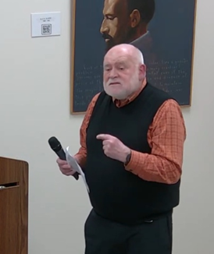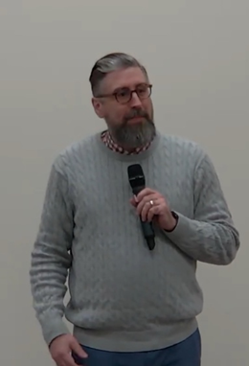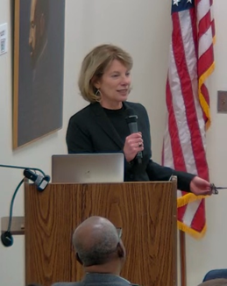

LibraryDirector Allen Deputy Mayor Linda Habgood Jerry Skotnicki, Chair of the BHM

McGinley Welcomes attendees Opens the first session. Celebration provides background

on the Portraits

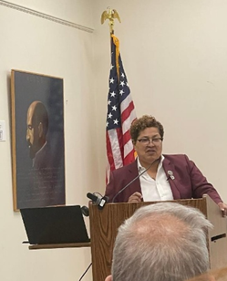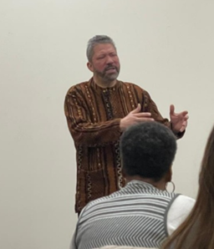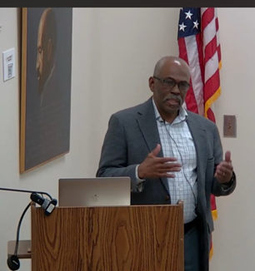

Professor Keith Walcott Brother Rob Tuck discusses Professor Rebecca Williams

Leads the first session on African American Impact on leads a discussion of African

the History of the Civil Rights Sports and Performing Arts American Impact on Literature

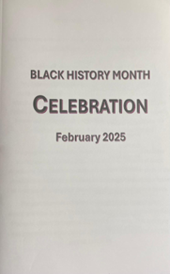 and Education

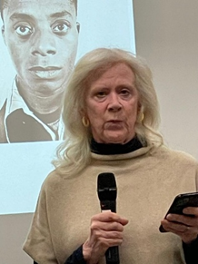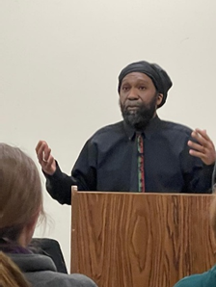

Jason Williamsoncloses the Marion Dillon Morris, Chair Black History Month

Program with a talk on the of the Americans Who Tell Celebration Program

Power of Social Activism the Truth discusses AWTT



The event you all have been waiting for! The Friends of the Westfield Memorial Library **50th** Annual Spring Book Sale is quickly approaching! And we can’t wait to see you all there.

We need your help to make the book sale a raging success. We want to make the book sale really special this year, and with your help, we can.We will need help setting up the room, sorting through donations, cashiering, assisting customers during the sale and cleaning up. Any time you can spare will be greatly appreciated. Please let your family and friends know about the sale in the hope that they will have books to donate and/or time to help out. We thank you in advance for spreading the word!If you have any questions, contact: info@fwmlnj.org.

**2025 Donation Days**

We will be accepting donations of **books in good condition** in a wide range of titles for all ages. What we **cannot** accept are textbooks, magazines, VHS tapes, encyclopedias or books that are torn, moldy, or damaged in any way.

Book donations can be dropped off on the sidewalk by the book drop boxes on the following dates and times:

**Wednesday, April 23 – 10 am – 2 pm**

**Thursday, April 24 – 10 am – 2 pm**

**Friday, April 25 – 10 am – 12 pm**

**Saturday, April 26 – 10 am – 1 pm**

**2025 Sale Days**

Last year we had over 25,000 books to choose from and once again, we will have books for infants, children, teens and adults. We will have fiction and non-

fiction; hardcovers and paperbacks; best-selling authors, classics, cookbooks, history, art, science, sports, gardening, self-help and much more! Our sale days are as follows:

**Wednesday, April 30 - 5 pm - 7 pm - Members Only Preview**

**Thursday, May 1 - 10 am - 7 pm - Teachers Discount**

**Friday, May 2 - 10 am - 4 pm - Teachers Discount**

**Saturday, May 3 - 10 am - 4 pm - Half Price Day**

**Sunday, May 4 - 1 pm - 3pm - Bag Day**

All remaining, unsold books will be donated.

**Volunteers**

We will need an amazing team of volunteers to work varying hours and to handle a wide range of tasks. We know we can count on you!

To volunteer please sign up at https://fwmlnj.org/book-sale-signup/ or if you have any issues, please email Amy Berman at amyjberman7@gmail.com. We welcome and approve community service hours.

Here are our much-needed tasks:

**Room Set Up** – Organize the room and get the bookcases and tables ready for books

.

**Sorting/Shelving** – Sort the books according to topic and put them in the assigned sections.

**Floor Support** – Assist customers looking for books and topics. Keep books organized and restock when needed.

**Cashier** – Tally up the cost of the customers’ purchases upon checkout, receive payment (cash, credit, PayPal), make change; and provide Friends membership information.

**Take Down/Clear Up** – Box leftover books for donations and for our Little Free Libraries, restore room to original condition and help to move tables and bookcases to storage locations.

*“I think books are like people, in the sense that they’ll turn up in your life when you most need them.” – Emma Thompson*

Thank you all in advance for helping us get books for everyone for when they need them the most! We would not be able to do this without you!

